Section 1: Pediatric Blunt trauma, Fall from height

Scenario Title: | Pediatric Blunt trauma, Fall from height
Keywords: | Blunt trauma, Intracranial hemorrhage, intra-abdominal injury, pediatric airway
Brief Description of Case: | Setting: community hospital.  A 2.5-year-old child falls from the 3rd floor (9m) balcony. The team is expected to coordinate a thorough trauma survey. The patient will initially demonstrate compensated hemodynamic shock requiring assertive resuscitation. After this initial phase, findings of severe head injury will become apparent. The focus of this scenario is cautious intubation and hemodynamic optimization in preparation for transfer of the pediatric polytrauma patient.  Note: this scenario can be tailored to more senior levels by adding complications of (1) parent in the room and (2) asking specific questions for transfer.

Goals and Objectives
Educational Goal: | To review the demonstrate the management of critical pediatric blunt trauma.
Objectives:  (Medical and CRM) | - Lead the resuscitation of a critically ill pediatric polytrauma patient.  - Demonstrate approach to primary and secondary trauma survey, recognizing signs of intracranial injury and compensated hypovolemic shock.  - Demonstrate definitive airway management and knowledge of rescue maneuvers (needle cricothyroidotomy) in the pediatric population  - Demonstrate understanding of limitations of pediatric FAST exam.  - Communicate priorities for transfer to center.
EPAs Assessed: | Core EPA #2: Resuscitating and coordinating care for a critically injured trauma patient  Core EPA #3: Providing airway management and ventilation

Learners, Setting and Personnel
Target Learners: | ☒ Junior Learners |  | ☒ Senior Learners |  |  | ☐ Staff
 | ☐ Physicians | ☒ Nurses |  | ☐ RTs | ☒ Inter-professional
 | ☐ Other Learners:
Location: | ☒ Sim Lab |  | ☐ In Situ |  |  | ☐ Other:
Recommended Number of Facilitators: | Instructors: 1-2
 | Confederates: 1 (nurse), 1 parent
 | Sim Techs: 1

Scenario Development
Date of Development: | 2020/08/05, performed with senior and junior residents 2020/09/15
Scenario Developer(s): | Audrey Marcotte
Affiliations/Institutions(s): | McGill University
Contact E-mail: | Audrey.Marcotte@mail.mcgill.ca
Last Revision Date: | 2020/10/02
Version Number: | 2

Section 2A: Initial Patient Information

- Patient Chart
Patient Name: Luke |  |  |  | Age: 2.5 | Gender: Male | Weight: 15kg
Presenting complaint: Fall from height. Withdrawing to pain and crying +++
Temp: 36.3 | HR: 135 | BP: 95/75 |  | RR: 30 | O₂Sat: 95% | FiO₂: RA
Cap glucose: 5 mmol/L |  |  |  | GCS: (E2 V3 M4 ) = 9 or AVPU “P”
Triage note:

A 2.5 year old patient brought straight to the resuscitation room after a fall from a 9m balcony. The child is crying, responding to pain, and is not yet on monitors nor do they have IV access.

Allergies: Peanuts
Past Medical History:  n/a |  |  | Current Medications:  n/a

Section 2B: Extra Patient Information

A. Further History
Mother can give information, but is very panicked.

Weight given if asked : 15kg
Vaccinated
No PMH, child was well before this.

Child playing on 3rd floor balcony next door to hospital. She picked him up and ran to hospital after he fell.
B. Physical Exam
Primary
A: Crying, primary teeth present, small amount of blood in nares.
B: Crying, hard to hear but clear lungs bilat, SPO2 98%
C: Tachycardic, warm extremities, strong pulses
D: Eye open to pain, +/- consolable but agitated, Withdraws to pain (E2 V3 M4 = 9) Pupils L4mm R4mm
E: No puncture wounds; bruising as described in secondary survey
Secondary
HEENT: Hematoma R brow with abrasions to R face. Small amount of blood in nares. C spine tenderness indeterminate.
Option to make Vomit x 1 during examination
Chest: Abrasion /bruise to R chest. No emphysema or crepitus.
Abdo: light bruising to R abdomen. Palpation soft, but child crying. Pelvis: Stable. No bruising or blood in perianal area.
Extremities: R arm bruising and pain R arm (screaming)
Logroll: No injuries noted.

Section 3: Technical Requirements/Room Vision

A. Patient
☒ Mannequin Pediatric
☐ Standardized Patient
☐ Task Trainer
☐ Hybrid
B. Special Equipment Required
Broselow tape
Cardiac Monitor / electrodes
Pediatric airway equipment (Nasal prongs + oxygen source, Non-rebreather mask, Bag valve mask, laryngoscope, ETT, ETCO2, suction)
Interosseous access, IV + tubing
BP cuff + SPO2
Screen to show imaging results

C. Required Medications
RSI medications:
- Possible options: ketamine, propofol, etomidate, fentanyl and midazolam
- Rocuronium 1mg/kg or Succinylcholine 1-2 mg/kg
Raised ICP management:
- 3% Saline 3ml/kg over 3 min or Mannitol (1g/kg/dose) over 20min
Seizure Prophylaxis:
- Phenytoin 20mg/kg, Levetiracetam 10/mg/kg
Volume resuscitation
- Blood (O negative 20mL/kg) or crystalloid
Analgesia
- Morphine 0.1mg/kg or fentanyl 1-2mcg/kg/dose
Antiemetic
- Ondansetron 0.15mg/kg or dimenhydrinate 1-1.5mg/kg

D. Moulage
Hematoma and abrasion R brown / head, R chest and abdomen

E. Monitors at Case Onset
☐ Patient on monitor with vitals displayed
☒ Patient not yet on monitor
F. Patient Reactions and Exam
A+B: Crying constantly, agitated, withdrawing from any attempts to console or touch patient. Patient should become less responsive and breathing should eventually become irregular as the case progresses (after primary survey is complete or ~3 minutes).

Palpation of R hemibody (face, arm, thorax and abdomen) should lead to more crying as this is where most soft tissue edema and discoloration is located.

Section 4: Confederates and Standardized Patients

Confederate and Standardized Patient Roles and Scripts
Role
Mother | Mood: Panicking and upset, feeling guilty for letting child fall off of balcony.  Disclosure: Gives any information that learners asks for but may go into irrelevant details (peanut allergy, rash with amoxicillin as a 1 year old. May distract / prompt team as patient becomes increasingly unresponsive – cry and distract more. If team member appropriately addresses mother’s concerns than mother will become less invasive.
Nurse | Informs MD she is not used to working with pediatrics.  Cannot obtain IV access.

Section 5: Scenario Progression

Scenario States, Modifiers and Triggers
Patient State/Vitals | Patient Status | Learner Actions, Modifiers & Triggers to Move to Next State |  | Facilitator Notes
1. Baseline State  Rhythm: NSR  HR: 150  BP: 95/68  RR: 30, regular  O₂SAT: 96%  T: 36.3ºC  GCS: E2 V3 M5 = 10  Glucose: 5.2 | Crying, agitated  Withdrawing from pain, resisting examination  Pupils 4mm bilat | Expected Learner Actions  Identify roles  C-spine precautions  Monitor, SPO2, apply O2  Obtain IV access: call for IO if unsuccessful  Obtain weight or use broselow tape  Primary Survey + Secondary survey  Call for social work/support for Mom  Try and keep child calm and reassured  Adjuncts/ investigations:  Ask for CXR / pelvis x-ray  e-FAST  Trauma labs  Ask mother for history /meds  Treatment:  PRBC 10-20cc/kg or crystalloid until blood available  Morphine 0.1mg/kg or fentanyl 1-2mcg/kg/dose  Warmer blanket | Modifiers  Changes to patient condition based on learner action  - Increase spo2 to 100% if mask given  - Decrease HR to 125 if blood given  -Decrease HR to 138 if analgesia given  - Decrease HR to 115 if both blood and analgesia given  Nurse prompts:  - No warmer -> prompt “he’s probably cold” Decrease temperature to 35.4 at next eval  - Call for IV-> prompt “I can’t get the IV, what other options there are?”  Triggers  For progression to next state  -Actions complete or after 3-4 min  Stage 2 -> Deterioration A | Primary survey should be done within 3 min  e-Fast will be positive for free fluid
2. Deterioration A  Rhythm: NSR  HR: 70  BP: 150/85  RR: 25, irregular  O₂SAT: 94%  T: 36.3ºC  GCS: E1 V2 M3 = 7  Glucose: 5.2 | Patient vomits x 1  Decreased agitation and responsiveness (Cushing Response)  GCS E1V2M3 = 7  Pupils: R 7mm L 4mm | Expected Learner Actions  Turn patient, suction airway  Prepare and intubate  - Discuss airway plan  - Pre-oxygenation  - Induction with Ketamine 1-2 mg/kg or agent of choice  - Paralysis (Roc 1mg/kg or suc 1-2mg/kg)  - Tube choice: size + cuffed  Repeat primary survey post intubation  Used shared mental model to tell team about concern for Cushing’s response  Measures to treat raised ICP vocalized:  - Head of bed elevated 30 degrees  - Hyperosmolar therapy  - Consider seizure prophylaxis  - Euglycemia, normocapnia, normothermia  Call Neuro Sx and Trauma team | Modifiers  - Intubation: Increase Spo2 to 100 %  - Raised ICP treatment measures done: HR to 100, BP to 135/85  Nurse prompt  - No plan to intubate -> prompt “I don’t think he is protecting his airway”  - No raised ICP treatment measures -> Prompt “Is there anything to do for his head/ why is he bradycardic?  Triggers  - Patient is not intubated by 8 min -> Deterioration B OR can have trauma leader call to prompt the team to acknowledge Cushing’s response and intubate  - Intubation and Neuroprotective measures done -> Disposition | Note: if team wants to do CT head prior to transfer, make note of this and discuss later  For Senior residents: Nurse can prompt about back up airway options
3. Deterioration B  Rhythm: Bradysystolic arrest / PEA  HR: n/a  BP: unreadable  RR: 0  O₂SAT: 88%  T: 35ºC  GCS: E1 V1 M1 = 3  Glucose: 4 | Patient unresponsive | Expected Learner Actions  PALS algorithm – compressions, epinephrine  Intubation as above | Modifiers  Nurse prompts  - No intubation -> Prompt to think about h’s and t’s and ask if it is related to a head injury  Triggers  -- Intubation -> Rhythm resumes NSR, pulse returns, move to post intubation | If no nurse for prompt, consider having facilitator end the case when it transitions to arrest to explore frames at that point
4. Post intubation and transfer  Rhythm: NSR  HR: 120  BP: 100/70  RR: 0  O₂SAT: 98%  T: 36.3ºC if warmer  35 if no warmer blanket  GCS: E1 V1 M1= 3T  Glucose: 3.2 |  | Expected Learner Actions  If intubated:  Post intubation CXR  Repeat primary survey  Repeat glucose + temp check  Sedation  Discuss case with neuro sx, arrange CT head at receiving site  Discuss transfer with trauma team  Transfer orders:  - Warming blanket  - Maintenance fluids  - Euglycemia  - C-spine precautions  - Avoid hypotension  - Hyperosmolar therapy  - Ventilation settings  Discuss transfer with Mother. | Modifiers  - NeuroSx to suggest neuro protective measures if not done so  - Trauma team to suggest Transfer orders if not done so  - Trauma team to prompt about other injuries (FAST results?)  Triggers  - End Scenario PRN

Appendix A: Laboratory Results

Glucose – given per stage

Initial :
VBG
pH 7.29
pCO₂ 45
pO₂ 95
HCO₃ 22
Lactate 4

No other labs available during scenario.

Appendix B: ECGs, X-rays, Ultrasounds and Pictures

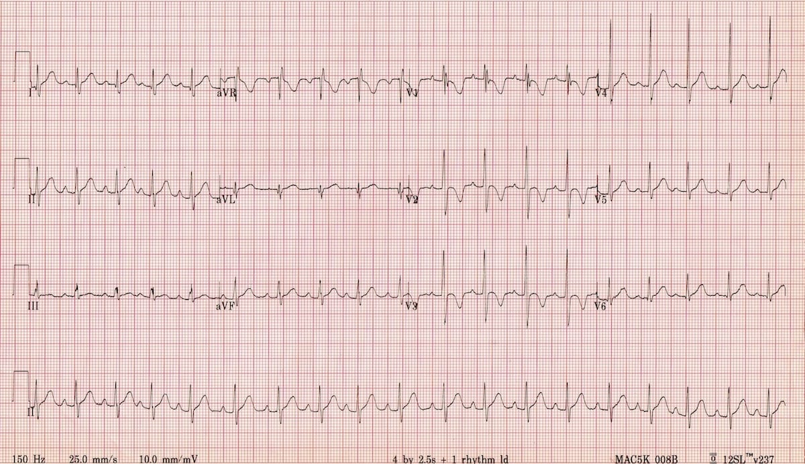

Source: https://litfl.com/paediatric-ecg-interpretation-ecg-library/

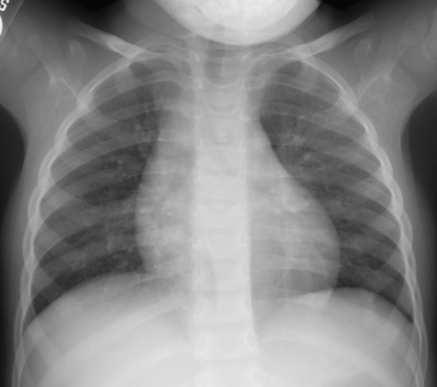

Source: http://bones.getthediagnosis.org/

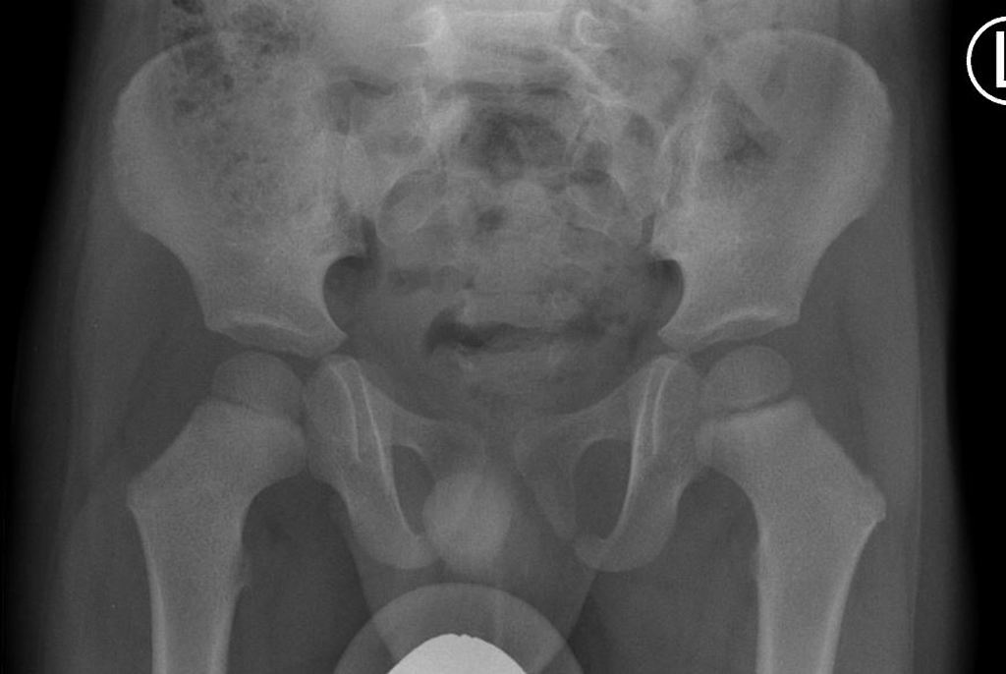

Source: https://radiopaedia.org/cases/normal-pelvic-radiograph-and-frog-leg-lateral-2-year-old?lang=us

E-FAST
Normal lung sliding
Small amount of free fluid RUQ
No pericardial effusion
Cardiac activity: hyperdynamic.

Appendix C: Facilitator Cheat Sheet & Debriefing Tips

Debrief Tips:
- The medical focus of this debrief is intra-abdominal and severe intracranial injuries. Below are possible discussion points for the junior or senior level regarding the pediatric polytrauma patient.

Start by asking one of the learners to summarize the case and describe what they thought was the patient’s main issue.

Medical Aspects
Common Pediatric Trauma issues:
- Broselow Tape and weight-based dosing - Ask learner how they decided on doses
- IV access – how to obtain intraosseus access? If learner had delayed vascular access, bring up how you can cognitively off-load the task up front giving clear criteria to the team “If we fail at 2 attempts, I’d like to proceed with IO at that point, please let me know if that’s the case” Video reference
Basics of Primary and Secondary survey in trauma
- Explore the learner’s frame when it comes to fluid resuscitation. Ask questions such as, “I noticed you decided to give crystalloid, can you tell me what your thought process was at that time”. Compensatory tachycardia with preserved BP indicating early hypovolemic shock in trauma scenarios. Also consider that this is a head injury and we might actually expect that this BP is representative of an early Cushing response. Blood (10-20mL/kg) preferable to crystalloid (20-40mL/kg) when you have trauma with tachycardia and signs of poor perfusion. Consider pain management.
- State your observation that there were multiple competing priorities and ask the team why they addressed things like temperature and glucose (if they did). Hopefully the learner’s did so because of unique pediatric physiology with large body surface area leading to hypothermia and increased metabolic rates leading to earlier hypoglycemia
- Pediatric GCS vs. AVPU scores. The GCS is a useful tool but can be complicated to remember. A good way to decrease cognitive load is using the AVPU score.
- C-spine precautions – c-spine injuries tend to be higher in children due to large occiput and flexible ligaments.

Pediatric airway management – Ask learner about airway management choice, “I noticed you had a robust airway plan up front. Pediatric patients are both easier and more difficult to intubate, can the team tell me what they were all thinking when planning for intubation”. Hopefully they will address pediatric airway differences including:
- Anatomical differences: Large occiput alters the position, large tongue and adenoid tissue, floppy epiglottis with anterior larynx, short trachea, narrow cricoid. Assure that pre-intubation positioning is appropriate to straighten the larynx and use a straight blade. Avoid pushing tube too distal as this can lead to right mainstem intubation.
- Percutaneous needle cricothyrotomy: The pediatric larynx is small and difficult to stabilize. Surgical cricothyroidotomy is contraindicated <8 years but may be performed in older children in which the membrane is palpable (10-12 years old). Needle cricothyrotomy should be considered as a rescue airway. Video reference

Traumatic head injury (severe) – If the team noticed the Cushing response late, ask, “ I noticed it took a while to recognize a Cushing response. When we have complex traumas, it can be hard to realize that there is a second injury causing changing physiology. I would like to explore if there was anyone on the team who may have been worried about this earlier, and it not, if there are any tools that we could use in the future to help recognize things like this sooner? “
- Signs of intracranial hypertension / herniation?
- Cushing Reflex - triad of bradycardia, hypertension, irregular respirations.
- Ipsilateral pupil dilation + contralateral hemiparesis (uncal herniation)

- Treatment for elevated ICP / signs of herniation?
- Head of bed at 30 degrees
- Treat pain and anxiety
- Treat seizures (phenytoin or levetiracetam for prevention; benzodiazepine as a fast-acting option)
- Hypertonic saline 3% 3-4ml/kg boluses. Mannitol is also an option.
- Normocapnia + hyperventilate (decrease PaCO2 to induce cerebral vasoconstriction) to target of pupillary constriction

- What Physiologic parameters should be monitored to protect the brain from secondary injury in severe head injury?
- Maintain euvolemia and normal systolic blood pressure
- Maintain normal oxygen saturation >90% and PACO2 35-40mmHG (unless signs of herniation)
- Prevent hypothermia with warmed fluids, blankets and overhead warmer.
- Euglycemia

Intrabdominal injury
- Interpretation of eFAST - Ask the learner how they interpreted the FAST and how it affected their management? Did this affect the team’s decision for volume expansion?
- Pediatric FAST has relatively low sensitivity. Requires repeat assessment and resuscitation if abnormal vitals.
- In contrast to adults, few intra-abdominal injuries warrant surgical intervention. Liver, splenic, and kidney injuries are generally self-limited. Focus should be placed on the hemodynamic assessment.
- Algorithm with regards to abdominal imaging:
- Positive FAST with a stable patient -> CT scan
- Positive FAST and decompensated shock -> straight to OR ; if resuscitation leads to stabilization-> CT
- Negative FAST with normal LFT’s and low suspicion -> serial examination; high clinical suspicion and elevated LFT’s -> CT

TXA in pediatrics? Ask learner if they thought about using TXA
- Not standard of care in pediatric polytrauma
- PED-TRAX – Military observational study of 766 pediatric patients suggesting an association with decreased mortality.
- No other study addressing TXA use in pediatrics, however some extrapolate CRASH-2 to adolescents within a 3-hour window.

Communication and crisis resource management
- Family Management – Having family members in the room can be very stressful, what are some tools that we can employ to deal with this additional stressor?
Family presence may reduce stress on families and the patient without compromising team dynamics or medical care. However, in a situation where family members are disruptive, it is important to delegate a team member to care for the family to avoid distraction from patient care.
- One really important CRM tool is that of setting dynamic priorities and this was especially true in this case. You can ask things like “I noticed there was a lot of information being fed back to the leader as things quickly evolved, what are some things that we can do as a team to make sure we are all on the same page and all in agreement of what the most pressing priority is”
- Team dynamics – Comment on closed loop communication, division of roles.
- Discussion with receiving team and transport – Comment on communication with consulting team.
If team opted to do scans prior to transferring – discuss that emphasis should be to move patient to definitive management (i.e. away from community center and to a tertiary care trauma center).

References

- Advanced trauma life support (ATLS®): the ninth edition. J Trauma Acute Care Surg. 2013;74(5):1363-6.
- Marx J, Walls R, Hockberger R. Rosen’s Emergency Medicine: Concepts and Clinical Practice. Elsevier Health Sciences; 2013.
- Jakob H, Lustenberger T, Schneidmüller D, Sander AL, Walcher F, Marzi I. Pediatric Polytrauma Management. Eur J Trauma Emerg Surg. 2010;36(4):325-38.
- Kochanek, PM et al. Guidelines for the acute medical management of severe traumatic brain injury in infants, children and adolescents – 2nd edition. Pediatric Critical Care Medicine, 13(1), (2012).
- Zebrack, M, Dandoy, C, Hansen, K, Scaife, E, Mann, NC, Bratton, SL. Early resuscitation of children with moderate-to-severe traumatic brain injury. Pediatrics, July; 124 (1); 56-64 (2009).
- Roberts I, Shakur H, Coats T, et al. The CRASH-2 trial: a randomised controlled trial and economic evaluation of the effects of tranexamic acid on death, vascular occlusive events and transfusion requirement in bleeding trauma patients. Health Technol Assess. 2013;17(10):1-79.
- Eckert MJ, Wertin TM, Tyner SD, Nelson DW, Izenberg S, Martin MJ. Tranexamic acid administration to pediatric trauma patients in a combat setting: the pediatric trauma and tranexamic acid study (PED-TRAX). J Trauma Acute Care Surg. 2014;77(6):852-8.
FOAM ED Resources:
- Helman A, Beno S, Alnaji F. Pediatric Trauma. Emergency Medicine Cases. May, 2017. https://emergencymedicinecases.com/pediatric-trauma-2/. Accessed [October 12, 2020].
- Thavanathan T, Hoang R, Helman A. Pediatric Cerebral herniation. Emergency Medicine Cases. March 2017. https://emergencymedicinecases.com/pediatric-cerebral-herniation/
- Mikrogianakis, A. Pediatric Trauma Pearls. Emergency Medicine Cases. https://emergencymedicinecases.com/video/emu-365-pediatric-trauma-pearls/. Accessed September 29, 2020.
- Tristan J, Thomas A. Pediatric Resuscitation. CanadiEM. October 20, 2016. https://canadiem.org/crackcast-e010-pediatric-resuscitation/. Accessed Sept 30, 2020.
- EM:RAP Productions. EZ IO Placement. [Youtube channel] May 20, 2016 (cited September 30, 2020). Available from https://www.youtube.com/watch?v=KHXSfh2ZRDM
- Heard, A. DrAMBHeardAirway. 01 Cannula Insertion. [Youtube Channel]. Dec 14, 2013 (cited September 30, 2020). Available from: https://www.youtube.com/watch?v=6LDEMmOcSB8&feature=youtu.be

